**Updated Design class diagrams**

1. Record payment

|  |
| --- |
| <<Controller>>  PaymentHander |
|  |
| +enterPaymentInfo(amt,tenderNo,payType,payDate)  +updatePaymentInfo(amt, tenNo,payType,payDate) |

|  |
| --- |
| account |
| -acc_no:double {key}  -acc_type:String  -acc_expDate:date |
| +getAccNumber(accNumber) |

|  |
| --- |
| admin |
| -user_no:int{key}  -user_username:String  -user_password:String  -user_surname:String  -user_fullname:String  -user_gender:String  -user_idNr:String  -user_email:String  -user_cellNr:double  -user_role:String |
| +enterPaymentInfo(amt,tenderNo,payType,payDate) |

|  |
| --- |
| payment |
| -pay_no:int {key}  -pay_date:date  -pay_amount:double |
| +updatePaymentInfo(amt,payDate,payType,tenderNo) |

2. make tender application

|  |
| --- |
| <<controller>>  applicationHandler |
|  |
| +searchTender(tenCategory)  +updateAppInfo(userNo,appNo,bidDocs) |

|  |
| --- |
| client |
| -user_no:int{key}  -user_username:String  -user_password:String  -user_surname:String  -user_fullname:String  -user_gender:String  -user_idNr:String  -user_email:String  -user_cellNr:double  -user_role:String |
| +searchTender(tenCategory)  +enterApplicationDet(userNo,appNo,bidDocs) |

|  |
| --- |
| tender |
| -ten_no:int {key}  -ten_desc:String  -ten_prov:String  -ten_postDate:date  -ten_closeDate:date  -ten_status:String  -ten_doc:String |
| getTenderInfo() |

|  |
| --- |
| application |
| -app_no:int {key}  -app_date:date  -app_status:String  -app_bid:String |
| +updateApplicationInfo(userNo,appNo,bidDocs) |

3. Approve tender

|  |
| --- |
| <<controller>>  approveTenHandler |
|  |
|  |

|  |
| --- |
| manager |
| -user_no:int{key}  -user_username:String  -user_password:String  -user_surname:String  -user_fullname:String  -user_gender:String  -user_idNr:String  -user_email:String  -user_cellNr:double  -user_role:String |
| +login(username,password)  +approveTender() |

|  |
| --- |
| tender |
| -ten_no:int {key}  -ten_desc:String  -ten_prov:String  -ten_postDate:date  -ten_closeDate:date  -ten_status:String  -ten_doc:String |
| +getApplicationInfo(appNo,appDate,bidDocs) |

4. Reward tender

|  |
| --- |
| <<controller>>  rewardTenHandler |
|  |
|  |

|  |
| --- |
| manager |
| -user_no:int{key}  -user_username:String  -user_password:String  -user_surname:String  -user_fullname:String  -user_gender:String  -user_idNr:String  -user_email:String  -user_cellNr:double  -user_role:String |
| +requestTenderDocs()  +rewardTender() |

|  |
| --- |
| tender |
| -ten_no:int {key}  -ten_desc:String  -ten_prov:String  -ten_postDate:date  -ten_closeDate:date  -ten_status:String  -ten_doc:String |
| +getTenderDocs(tenderDocs) |

5. view tender

|  |
| --- |
| <<controller>>  viewTenHandler |
|  |
|  |

|  |
| --- |
| category |
| -cat_no:int {key}  -cat_desc |
| +getCategory() |

|  |
| --- |
| client |
| -user_no:int{key}  -user_username:String  -user_password:String  -user_surname:String  -user_fullname:String  -user_gender:String  -user_idNr:String  -user_email:String  -user_cellNr:double  -user_role:String |
| +selectCategory(category)  +viewTenderInfo(tenDesc,closingDate,tenNo) |

|  |
| --- |
| tender |
| -ten_no:int {key}  -ten_desc:String  -ten_prov:String  -ten_postDate:date  -ten_closeDate:date  -ten_status:String  -ten_doc:String |
| +getTenderDet(tenDesc,closingDate,tenNo) |

6. add client

|  |
| --- |
| <<controller>>  clientHandler |
|  |
| +createAccount(name,email,contacts,addresses) |

|  |
| --- |
| company |
| -comp_no:int {key}  -comp_name:String  -comp_type:String  -comp_street:String  -comp_surburb:String  -comp_prov:String  -comp_code:int |
| +updateCompanyDet(compNo,  compName,contacts,addresses) |

|  |
| --- |
| admin |
| -user_no:int{key}  -user_username:String  -user_password:String  -user_surname:String  -user_fullname:String  -user_gender:String  -user_idNr:String  -user_email:String  -user_cellNr:double  -user_role:String |
| +createAccount(name,email,contacts,addresses) |

|  |
| --- |
| account |
| -acc_no:double {key}  -acc_type:String  -acc_expDate:date |
| +updateClientInfo(userNo,name,email,contacts,addresses) |

**Detailed sequence diagram**

1.Record payment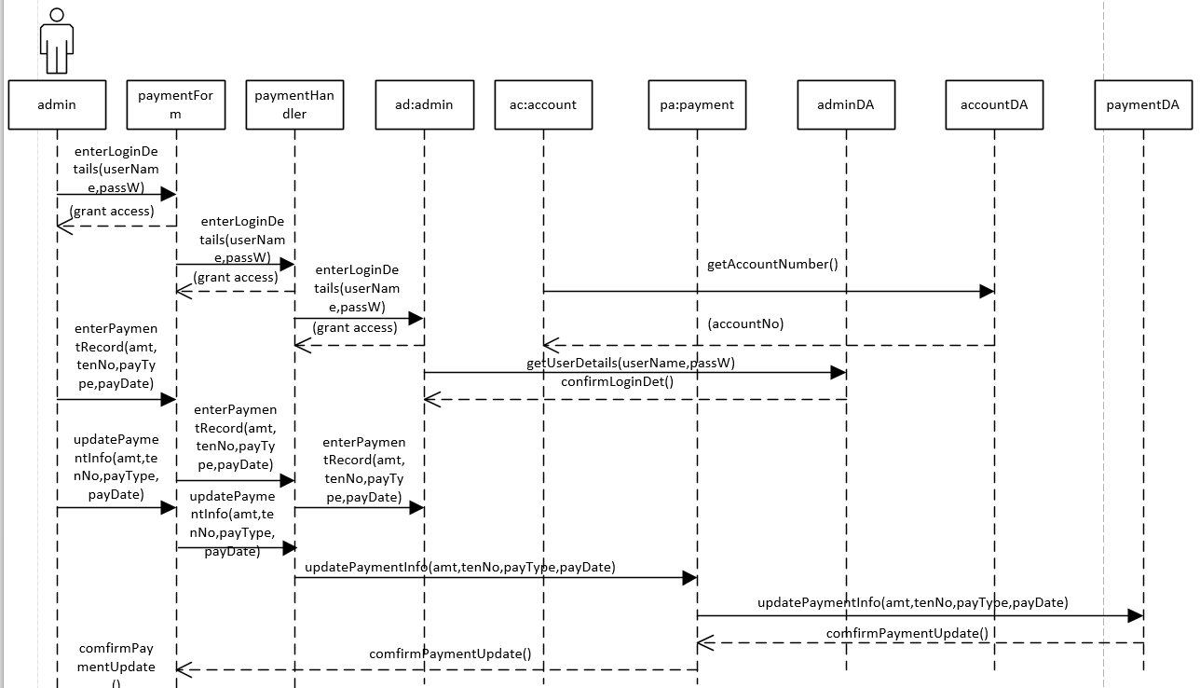

2.make tender application

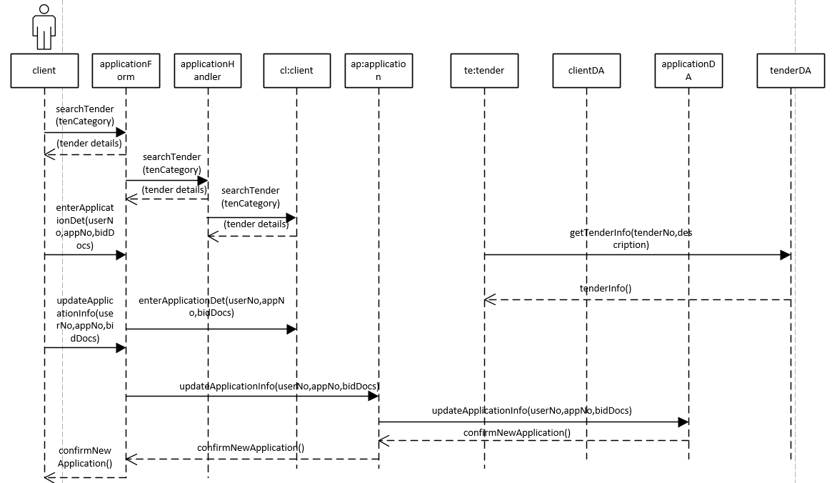

3. approve tender

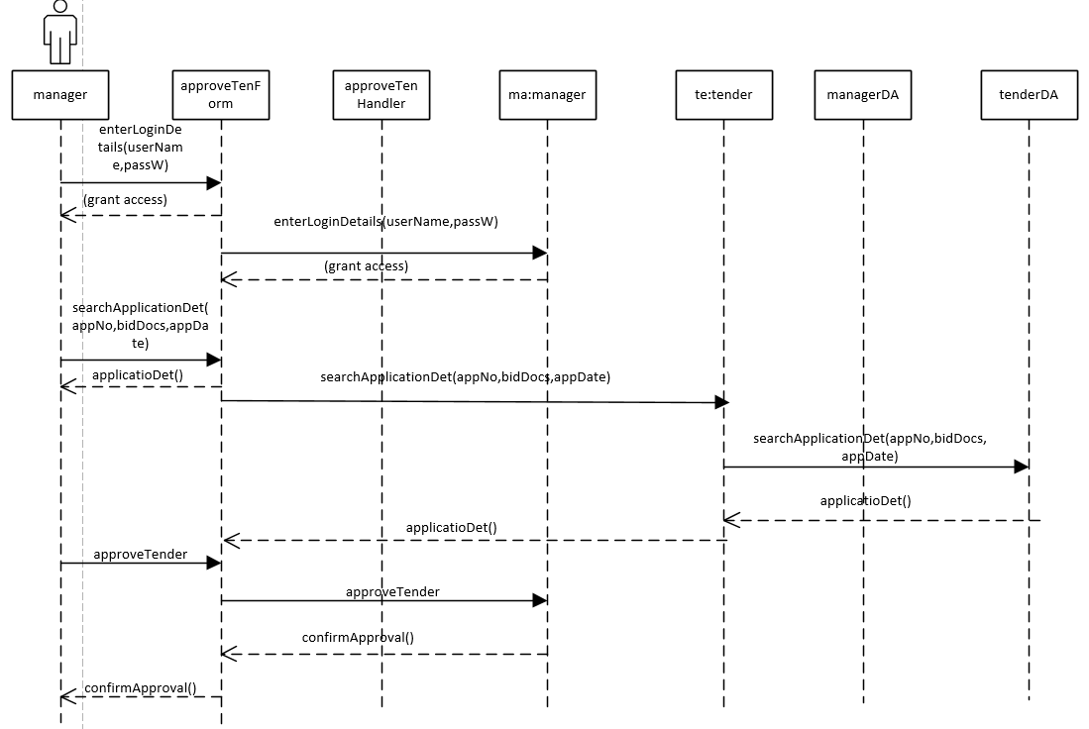

4. reward tender

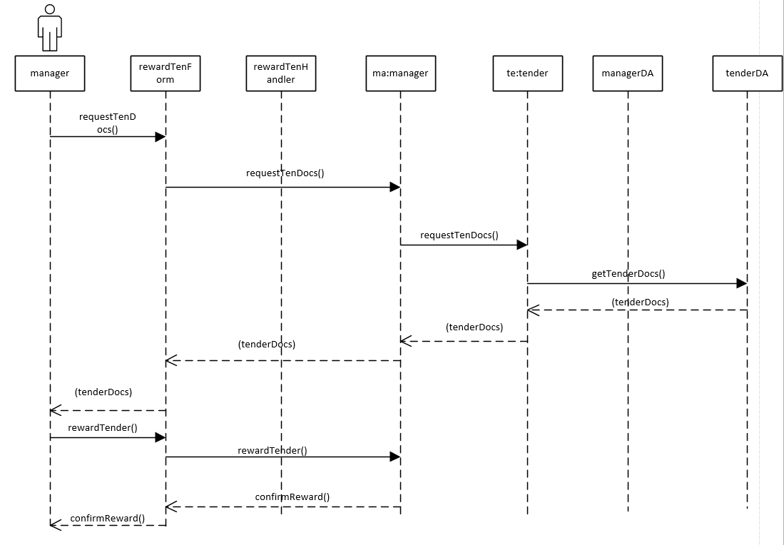

5.view tender



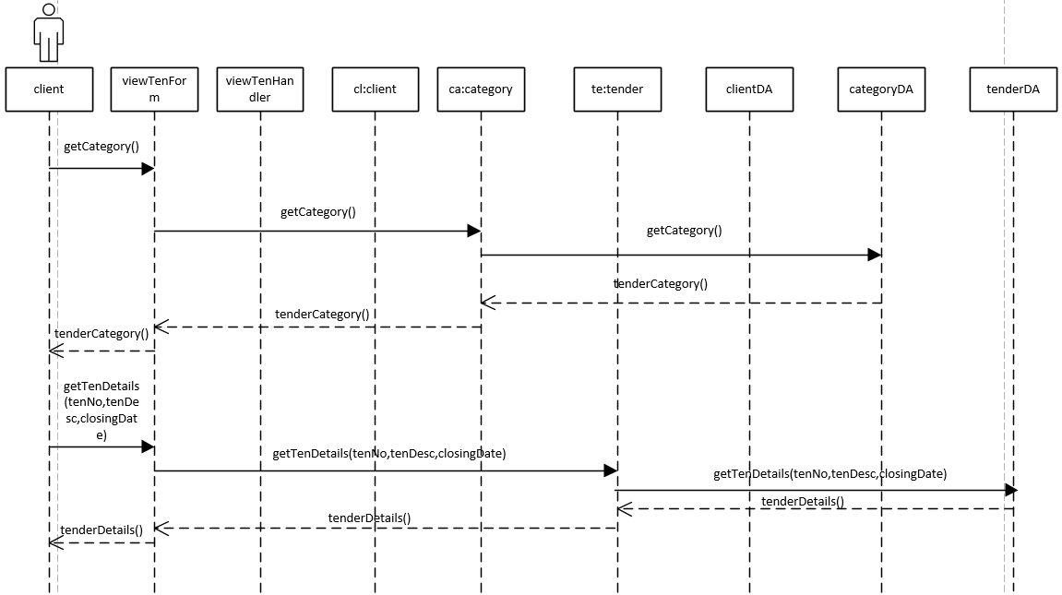

6.Add client

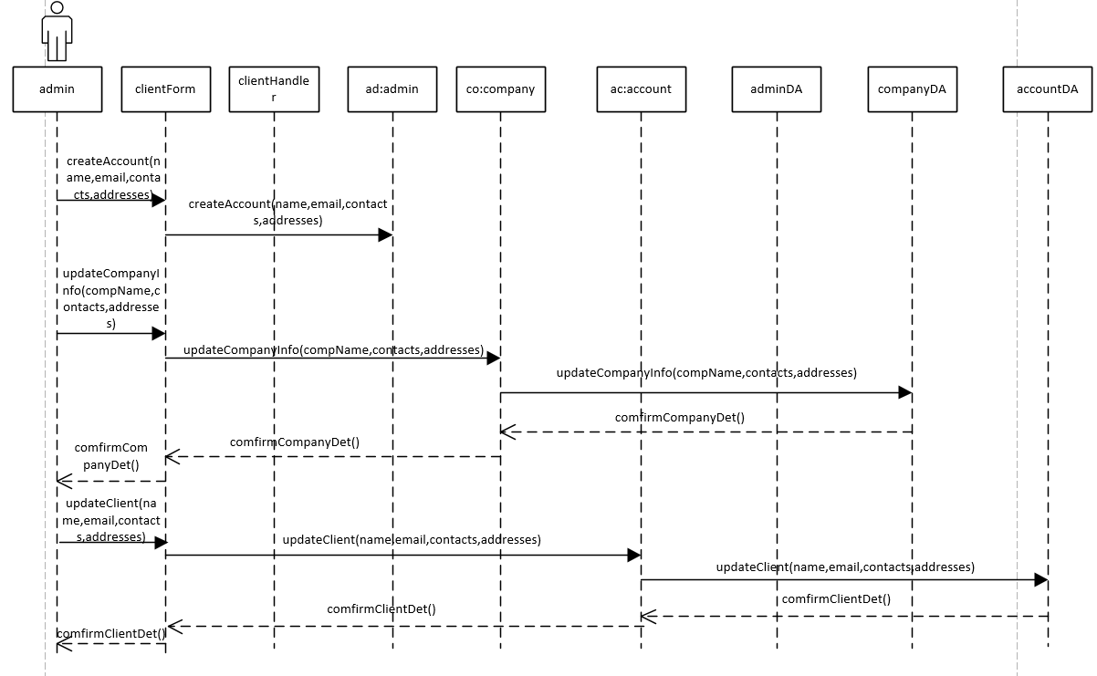

**Package Diagrams**

1.Record Payment

|  |
| --- |
| View Layer |

paymentForm

|  |
| --- |
| Domain Layer |

payment

account

admin

paymentHandler

|  |
| --- |
| Data access layer |

paymentDA

adminDA

accountDA

2.Make tender application

|  |
| --- |
| View layer |

applicationForm

|  |
| --- |
| Domain layer |

aaplicationHandler

tender

client

application

|  |
| --- |
| Data access |

tenderDA

applicationDA

clientDA

3.Approve tender

|  |
| --- |
| View layer |

approveTenForm

|  |
| --- |
| Domain layer |

approveTenHandler

tender

manager

|  |
| --- |
| Data access layer |

managerDA

tenderDA

4.Reward tender

|  |
| --- |
| View layer |

rewardTenForm

|  |
| --- |
| Domain layer |

tender

manager

|  |
| --- |
| Data access layer  tenderDA |

managerDA

5. View tender

|  |
| --- |
| View layer |

viewTenForm

|  |
| --- |
| Domain layer |

tender

category

client

viewTenHandler

|  |
| --- |
| Data access layer |

tenderDA

categoryDA

clientDA

6. Add client

|  |
| --- |
| View layer |

clientForm

|  |
| --- |
| Domain layer |

account

company

admin

clientHandler

|  |
| --- |
| Data access layer |

adminDA

companyDA

accountDA